# Name: ________________________

# Talking Tariffs

Example #1 – China 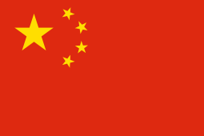

|  |  |  |  |
| --- | --- | --- | --- |
|  | Price of pork sold by farmer | Tariff charged | Price of pork bought by consumer |
| Image result for us. flag |  |  |  |
| Image result for south korea flag |  |  |  |

1. If you were a Chinese consumer, which pork would you buy?
2. Do the Chinese tariffs help or hurt the U.S. pork industry?
3. Do the Chinese tariffs help or hurt China?
4. How can the U.S. address this problem?

Example #2 – Japan 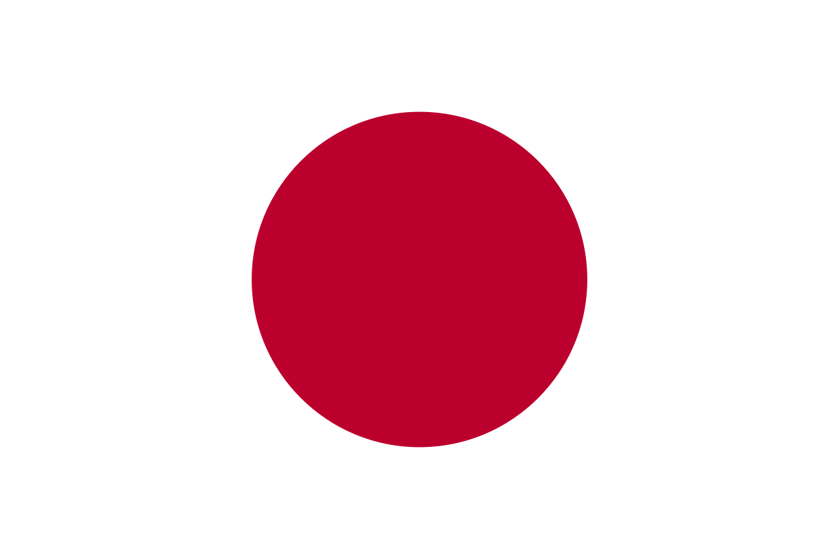

|  |  |  |  |
| --- | --- | --- | --- |
|  | Price of pork sold by farmer | Tariff charged | Price of pork bought by consumer |
| Image result for us. flag |  |  |  |
| Image result for eu flag |  |  |  |

1. If you were a Japanese consumer, which pork would you buy?
2. Does the Japan-EU agreement help or hurt the U.S. pork industry?
3. Does the Japan-EU agreement help or hurt Japan?
4. How can the U.S. address this problem?